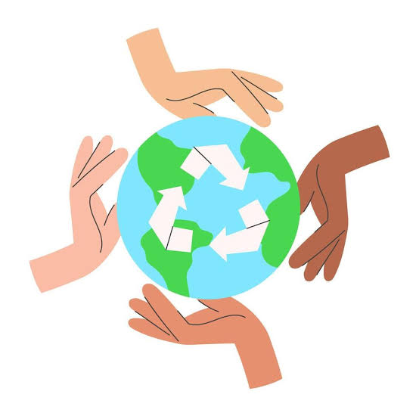
PROJECT DOCUMENTATION
RECYCLABLE WASTE
CLASSIFICATION
USING VGG16

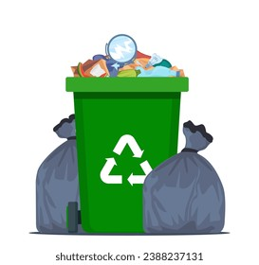








AUTHOR
Swetha.V
DATE
11-07-2026
DOCUMENT ID
TW - 007
Easy to Use
Simple and user-friendly interface suitable for students, researchers, and environmental organizations.

Eco-Friendly Solution Promotes proper waste segregation and encourages responsible recycling practices.

Fast Prediction Processes uploaded images within seconds to provide real-time predictions.

Accurate Classification
Uses the VGG16 deep learning model to classify recyclable waste images with high accuracy.

A Deep Learning-Based Image Classification System
This project presents a deep learning solution for automatically classifying recyclable waste into predefined categories using the VGG16 Convolutional Neural Network. The system assists users in identifying recyclable materials quickly and accurately, supporting efficient waste segregation and environmental sustainability.

I. PROJECT OVERVIEW
I. PROJECT OVERVIEW
1. Project Overview
The Recyclable Waste Classification system uses the VGG16 Convolutional Neural Network (CNN) to automatically classify waste images into recyclable categories. The model analyzes uploaded images, extracts visual features, and predicts the appropriate waste category, reducing manual effort and improving recycling efficiency.
Objective : The primary objective of this project is to develop an intelligent image classification system capable of accurately identifying recyclable waste materials using deep learning techniques. The project aims to improve waste management processes while demonstrating the practical application of artificial intelligence in environmental sustainability.

2. Intended Users
- Students
- Researchers
- Environmental Organizations
- Waste Management Companies
- AI & Machine Learning Learners
- Developers

3. Key Features
Feature | Description
Image Classification | Classifies waste images into recyclable categories.
Deep Learning Model | Uses the VGG16 Convolutional Neural Network.
High Accuracy | Produces reliable classification results.
Fast Prediction | Generates predictions within seconds.
User-Friendly Interface | Interface for uploading and classifying image.

II. SYSTEM DETAILS

1. System Requirements
Requirement | Specification
Operating System | Windows 10 or later
Programming Language | Python 3.x
RAM | 8 GB or higher
Processor | Intel Core i5 or equivalent
GPU (Optional) | NVIDIA GPU with CUDA support
Libraries | TensorFlow, Keras, OpenCV, NumPy, Matplotlib
Storage | At least 5 GB available space

2. Work Flow




Image Preprocessing : The image is resized and normalized for better prediction.
Upload Image : Upload a recyclable waste image through the application.

Feature Extraction (VGG16) : The VGG16 model extracts important visual features from the image.
Prediction : The trained model predicts the waste category based on learned patterns.


Display Result : The predicted waste category is displayed along with the confidence score.

III. IMPLEMENTATION DETAILS
1. Dataset
The dataset contains images of recyclable waste collected from publicly available sources. Images are grouped into multiple recyclable categories and divided into training, validation, and testing datasets.
Organic
Glass
Plastic
Paper
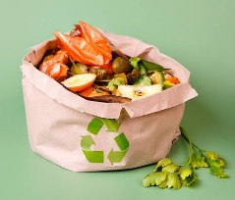
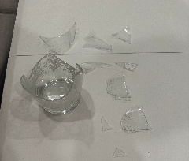
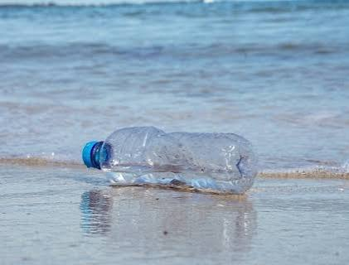
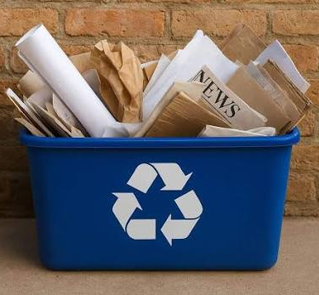

Hazardous
Electronic
Metal
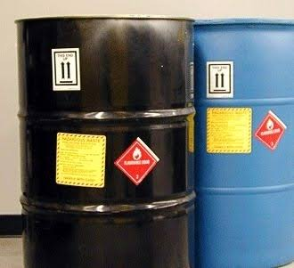
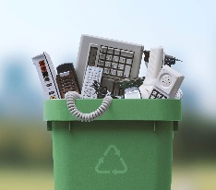
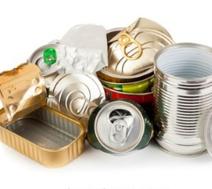

2. Architecture of VGG16
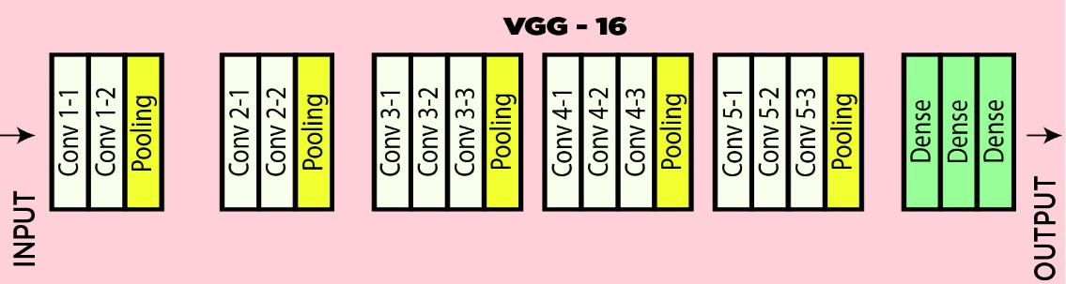
The project uses the pre-trained VGG16 Convolutional Neural Network with 16 layers. The pre-trained VGG16 model (trained on imageNet) is used and fine-tuned for our classification task.

3. Training Configuration
- Optimizer : Adam
- Loss Function : Categorical Crossentropy
- Batch Size : 32
- Epochs : 50
- Learning Rate : 0.0001

IV. RESULTS & CONCLUSION
1. Output
The system accepts an uploaded image as input and predicts the appropriate recyclable waste category with a confidence score. The prediction results help users correctly identify recyclable materials for proper waste disposal.

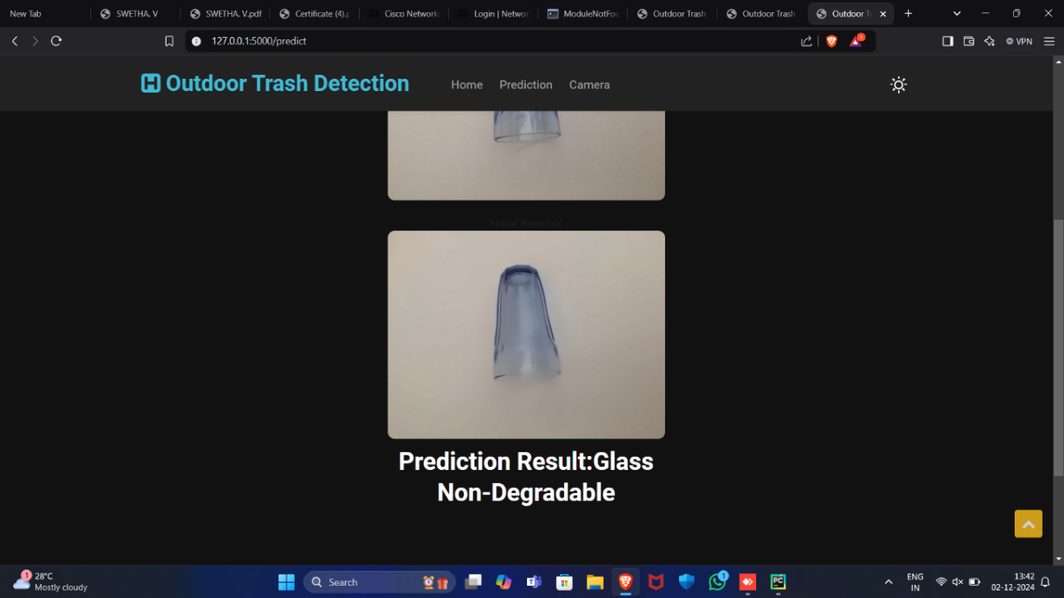

2. Performance Metrics
Metric | Value
Accuracy | 96.87%
Precision | 96.23%
Recall | 96.54%
F1-Score | 96.38%

3. Future Enhancements
- Add additional recyclable waste categories.
- Develop a mobile application for real-time predictions.
- Integrate IoT-enabled smart waste bins.
- Improve classification accuracy using larger datasets.
- Explore more advanced deep learning architectures.
Conclusion
The Recyclable Waste Classification Using VGG16 project demonstrates how deep learning can automate waste classification with speed and accuracy. By supporting efficient waste segregation, it highlights the practical role of Artificial Intelligence in promoting environmental sustainability.

